

(GEO-LOCATION BASED SMART PARKING SYSTEM)

## A synopsis submitted in partial fulfillment of the requirement for the award of the degree of

**Bachelor of Technology** **In**

**Electronics and Communicatio­­n Engineering**

**BY: MANISH GOEL (20715602818)**

**AYANABHA PAUL (20415602818)**

**ARYAN GANDHI (35215602818)**

**HARSHIT BAJAJ(20815602818)**

**ECE-T4, 8th Semester (2022)**

­

**Dr. Akhilesh Das Gupta Institute of Technology &**

**Management**

**Guru Gobind Singh Indraprastha University Dwarka, New Delhi-110078**

**Aim:** PARKESY is a Geo-location Based Smart Parking System (GBSPS) that enables customers/drivers to reserve a parking space.

# Requirements:

# SOFTWARE

* ReactJS
* Advanced CSS/SasS
* MongoDB
* Mongoose
* ExpressJS
* Redux(state management tool)
* GIT(VCS)

**HARDWARE**

* Arduino uno
* HC-SR04 distance measurement sensor
* ESP8266 microcontroller

**About**: PARKESY has a clear vision of the future: We connect Parking, Mobility and Urban life by providing innovative, smart solutions to our clients and their customers.

At PARKESY our mission is to achieve this vision by striving to not just be a mere service provider, but a reliable and trusted partner. We offer a comprehensive range of innovative services and products for our clients and customers. Integrity and loyalty are indispensably part of our company philosophy

PARKESY is a Geo-location Based Smart Parking System (GBSPS) that enables customers/drivers to reserve a parking space

PARKESY was developed because the congestion and collision of the vehicle, the system was developed for people of Delhi. Therefore, the project aimed at solving such problems by designing a web-based system that will enable the customers/drivers to make a reservation of available parking space

# Application:

* Government approved parking lots
* Extra available parking at Malls and Hotels
* Parking at housing society

# Block Diagram :

## 

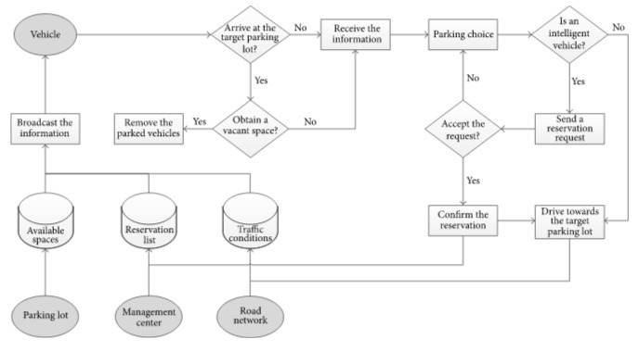

# Conclusion:

The efforts made in the project are focused mainly on improving a city’s parking facilities and thus aiming to improve its people’s quality of life.

In this project, we addressed the parking issue and present a integrated smart parking system based on IoT